1. N – 1 – (K – 1) = N – K

2.

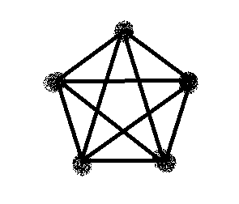 Answer: 16

1 3 4 5 2

1 3 5 4 2

1 3 4 2

1 3 5 2

1 3 2

1 4 3 5 2

1 4 5 3 2

1 4 3 2

1 4 5 2

1 4 2

1 5 4 3 2

1 5 3 4 2

1 5 4 2

1 5 3 2

1 5 2

1 2

3. As we know, if vertex in connected graph has two edges, there will be cycle graph. In cycle graph, there isn’t bridge, because if we delete another vertex, there won’t be two connected components and no bridge. Answer: 0.